For further enquiries contact Hugh on 07849518180 or Leo on 07543070863
You can also message our Facebook page and check it for updated information.

Comhaltas Craobh Boirche, Mourne | Facebook

https://www.facebook.com/
ComhaltasCraobhBoirche/

What do we teach? - Traditional Irish/Scottish Reels Jigs Hornpipes, Polkas, Mazurkas. Slow Airs, Christmas Carols and Folk music
If you have always wanted to learn an instrument then now is your chance. Come along for a complimentary class to see what we do. We have lots of parents and grandparents learning alongside their children
Grupa Ceol (Music Group)
Each week we have a multi-instrument group performance where young children (and adults) learn how to play together in a fun atmosphere.

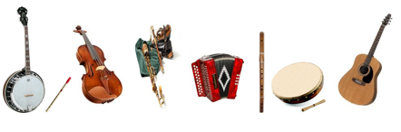

Comhaltas Ceoltoiri Eireann (CCE). Founded in 1951 CCE has 420 branches worldwide in Ireland, Great Britain and North America. It is a non-political, non-religious voluntary organisation whose members have a love of Irish and Celtic traditional song, music, dance and language and the desire to encourage others to learn and enjoy this rich tradition.
Our local branch of Comhaltas was established in 1978.
Classes are held on Tuesdays during term-time from 7-9pm in Moneydarragh Hub, Longstone Road
Registration for 2021/2022 classes is on Tuesday 7th Sept from 7.30 -8.30pm. Classes begin on Tuesday 14th Sept.

Comhaltas
Craobh Boirche
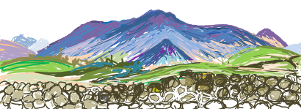
The Mourne Branch of
Comhaltas Ceoltóirí Éireann
Traditional Music
Do you want to Learn to play an Instrument?
Classes for 2021/2022

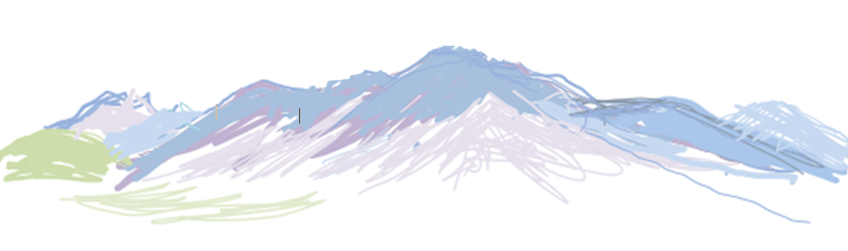
Comhaltas Craobh Boirche music classes run on Tuesday nights, from 7:00 –9:00 pm. Classes are held in Moneydarragh Hub, 101 Longstone Road, Annalong. Each lesson lasts approximately 40 minutes and there are lessons for different levels of ability in most instruments.
We provide high quality tuition from beginner to advanced level in;
Tin whistle, Flute, Bodhran,
Fiddle, Banjo, Trad Guitar
Uilleann Pipes, Button Accordion
Piano Accordion Concertina and Harp
All Instruments can be hired for a small deposit and small weekly hire rate.
===================================
Disabled/ Special Needs Children’s Classes. Children/Adults with Special Needs or Disabilities are welcome to attend classes and to learn to play an instrument in a safe supportive environment
A Safe Learning Environment for Children
Boirche has a team of very experienced and qualified tutors along with a number of volunteers who help to supervise classes and monitor the well-being, behaviour and safely of our younger / vulnerable members.
Tutors, Committee members and volunteers are Access NI vetted and Boirche has in place a Safeguarding Policy and two trained safeguarding officers to ensure compliance with its Safeguarding Policy.

Class fees for this year are £5:00 per lesson discounted to £4/class for additional classes/family members. People with disabilities are welcome and there is no upper age limit. Children need to be in P3 or above in order to benefit from lessons.
Membership fees are £10 adult, £6 child and £16 family

Craobh Boirche organises music sessions and takes part in other events such as the Comhaltas County Concert. We encourage musicians to enter the County Fleadh competition, and we keep members updated about traditional music workshops and concerts in our region.
Monthly Music Session
on 2nd Sunday of Each Month commencing Sunday 10th October 2021
in Moneydarragh Hub
6-8 pm.
Everyone is welcome – admission is free for children,
Adults £2 donation please for Tea/Coffee and Biscuits

Class fees are subsidised to keep costs down – please support our fundraising e

