[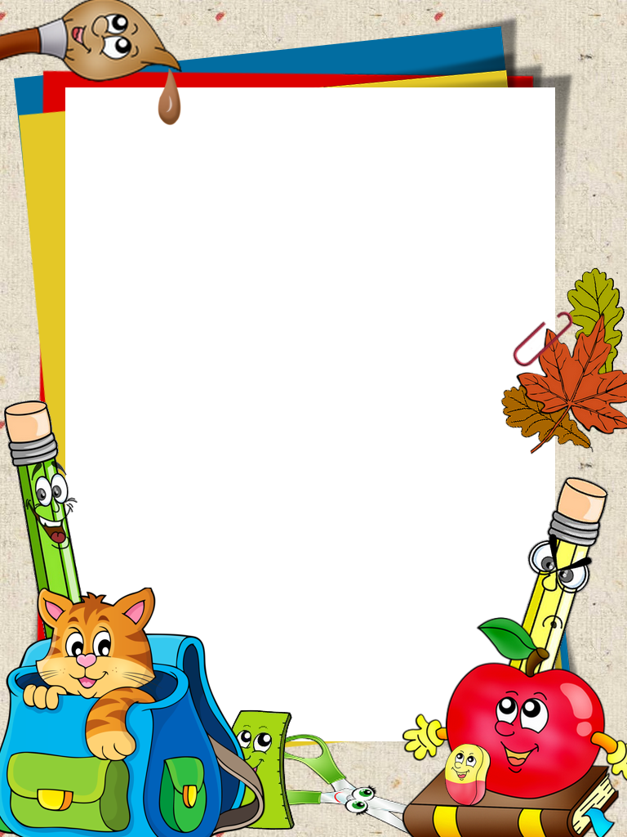](https://www.google.co.uk/url?sa=i&url=https%3A%2F%2Fwww.pinterest.com%2Fpin%2F420242208975113154%2F&psig=AOvVaw3CiWaA4xSRbsFZk-__9qYk&ust=1599035980963000&source=images&cd=vfe&ved=0CAIQjRxqFwoTCNCsmLrHx-sCFQAAAAAdAAAAABAP)

Tuesday 1st September 2020

Dear God,

This is my first letter to you. I only write a letter to Santa.

We are all back to school today. It is GREAT! Thank you God for our school. Keep us all safe this year.

Love from all the boys and girls in St Colman’s xx