To Download our school App.

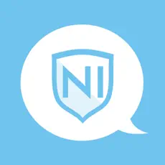
Schools NI

- Go to the app store

- Search for Schools NI app ( as above )

- Choose St Colman’s PS Kilkeel

